RESOLUTION NO.__________

RE: CERTIFICATE OF APPROPRIATENESS UNDER THE
PROVISIONS OF THE ACT OF THE PENNSYLVANIA
LEGISLATURE 1961, JUNE 13, P.L. 282 (53
SECTION 8004) AND BETHLEHEM ORDINANCE NO.
3952 AS AMENDED.

WHEREAS, it is proposed to install new storefront signs showing the “Jackson Hewitt” business logo at 425 Wyandotte Street.

NOW, THEREFORE, BE IT RESOLVED by the Council of the City of Bethlehem that a Certificate of Appropriateness is hereby granted for the work.

Sponsored by: (s)

(s)

ADOPTED BY COUNCIL THIS DAY OF

(s)
President of Council

ATTEST:

(s)
City Clerk

HISTORIC CONSERVATION COMMISSION

CASE # 576– It is proposed to install new storefront signs showing the “Jackson Hewitt” business logo at 425 Wyandotte Street
OWNER/APPLICANT: Robert Schubach

The Commission upon motion by Mr. Evans seconded by Mr. Cornish adopted the proposal that City Council issue a Certificate of Appropriateness for the proposed work described herein:
- The proposal to install new storefront signs showing the “Jackson Hewitt” business logo at 425 Wyandotte Street was presented by Robert Schubach.
- The new signs will be individually lettered vinyl window signs located on each display window slightly above center. There will be no solid white background as originally proposed.
- The signs will be reduced in size so that there is approximately 6” of empty space at either end of the signs (12” shorter than the width of the glass).
- The business name will have blue lettering and the tagline white. A border in white of blue will be added around the sign.
- The promotional sign on the door should will be removed and placed on an easel in one of the display windows.
- The “OPEN” sign will be more carefully placed in the storefront window so that it does no compete with the new vinyl signs.
- The proposed motion was unanimously approved.

CU: cu
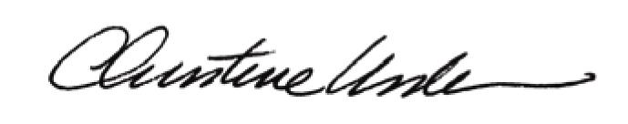

By:

Date of Meeting: January 25, 2016 Title: Historic Officer

